# 

# 

# **1.Project Introduction**Aerobatics competition is a heated discussion worldwide. However, devices which can help pilots to enhance their aerobatics skills are very limited. Thus, equipments, which can replay pilots’ maneuver and specific flight paths while showing the pilot’s input, are very needed.

**2.Our Solution**

* Raspberry Pi – Data processing unit & Data storage
* IMU – Collect aircraft orientation
* GPS – Collect aircraft position & ground speed
* Camera – Collect airspeed & polite input
* Touch Screen – Hardware control & Data display

**3.System Structure**

**4. Flight Stick and Rudder Cable tracking**

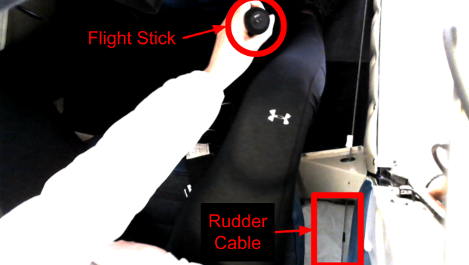

Track the movement of the tip of the flight stick and the tape on the rudder cable

**5. Dial reading**

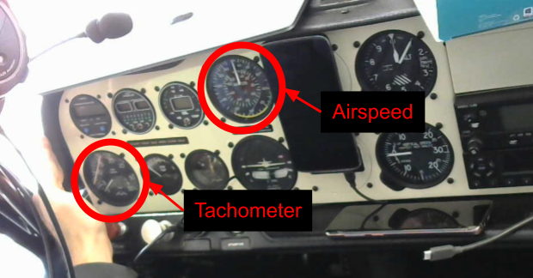

Dials in the image, and record the angles of the needles

**6.Future Work**

* Improve data filtering/smoothing by including pilot input in the data model
* Expand the image processing algorithms to work from different camera angles
* Update the UI